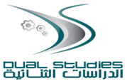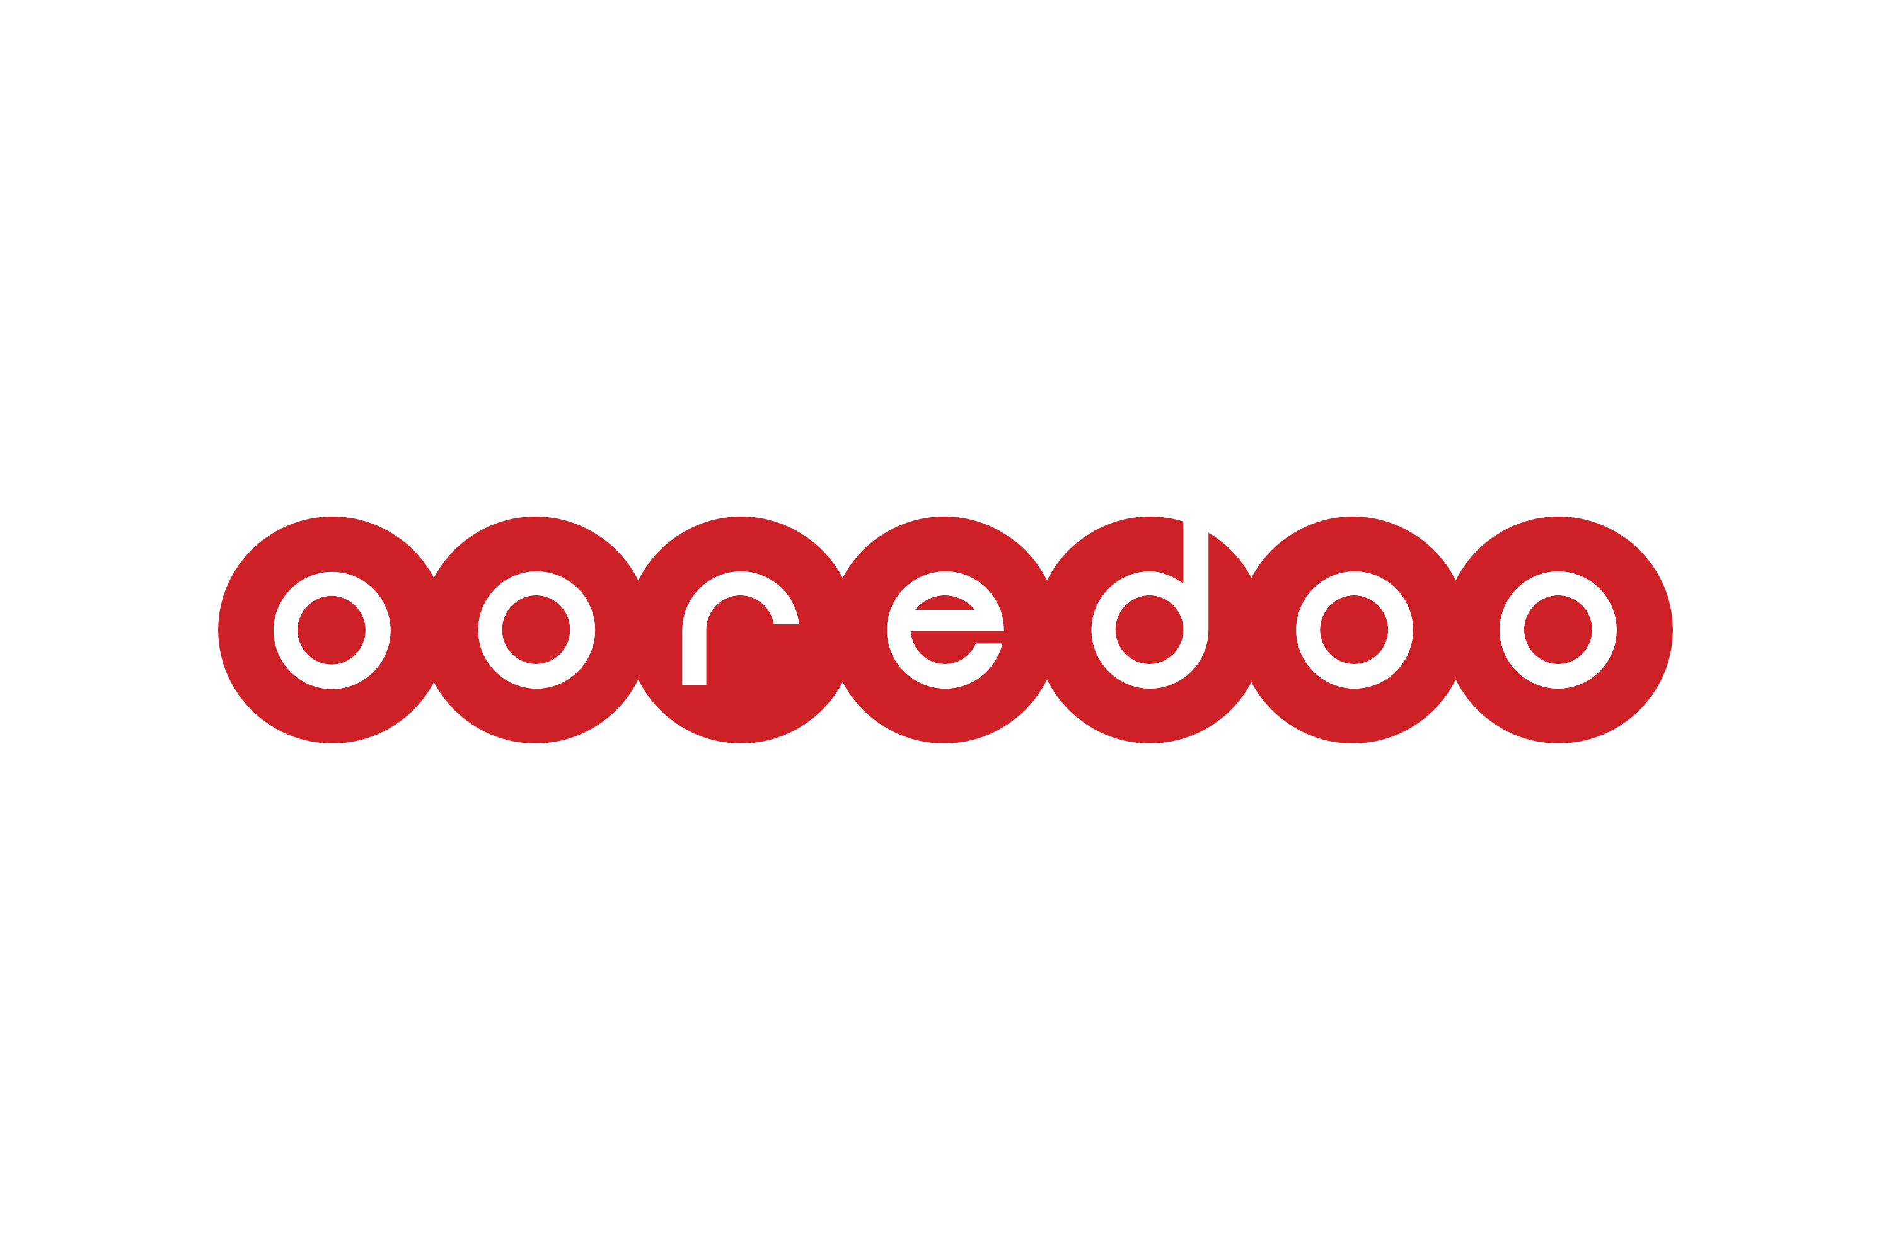

Practical Period Report-Final

Practical Phase No.:
Two (2)
Academic year:
(2023/2024)
Program:
DSIT
Partner Company:
Ooredoo
Submitted To:
Dr. Raid Zaghal
Prepared By:
Student Name: Mohammad Almasri
Student Number: 22212237
Signature:

Table of Contents:
- Introduction
- About Al-Quds University.
- About Ooredoo company.
- About Dual Studies.
- About Information Technology
- Why writing this report.

- Performed activities /Tasks

- Lessons learned

- Obstacles

- Recommendations
- Recommendation for Al-Quds University and Ooredoo Company.
- Recommendation for me.

- Appendices

1. Introduction
- About Al-Quds University:
Al-Quds University, founded in 1984, is a Palestinian university, and the only university in the world to be situate by a separation wall. The university contains fifteen academies spread over four locations; these colleges accommodate more than thirteen thousand students from the Jerusalem area and from the areas of Bethlehem, Hebron, Jenin, Jericho, Nablus, Ramallah, Tulkarm and Qalqilya.

Al-Quds University offers a vibrant learning environment for its students while creating a nucleus for creativity, exchange of ideas, freedom of expression and innovation in research. Its vision is to continue to provide students with the best possible education methods, to instill the values ​​of committed citizenship, openness to new ideas, stimulate constructive cooperation, and respect for world cultures. Al-Quds University, in its continuous try to enhance the educational model and methods of teaching used, has established several partnerships with American and European educational institutions. More than 30 centers and institutes linked to the university, some of which work to establish innovative research and others work to meet societal needs through the provision of help to the Jerusalem community.

- About Ooredoo company:
Formerly known as Wataniya Mobile, Ooredoo Palestine launched its commercial services in November 2009 in the West Bank, we work at Ooredoo to offer a range of services and products tailored to the needs of individuals and businesses in Palestine. We offer subscribers complete and easy to use communication software that gives them real value as well as best coverage, best quality and best services.\

- About Dual Studies:
Dual studies is an educational system that combines the theoretical study with the practical application. Al-Quds University launched the Dual Studies in 2015 with funding from the German Government through GIZ.

Dual Studies have been designed to contribute to raising the professional level of the Palestinian youth and providing good jobs for students after graduation. Moreover, it aims to bridge the gap between the academic educational outcomes and the needs and requirements of the Palestinian labor market.

Dual studies is being implemented as in the German experience which depends on the integration of academic study and linking students in the work environment since the first day of enrolling to the specialty. All, which provides students with the opportunity to study at Al-Quds University as well as have the chance to practice the profession their studies, suggest in one of the specialized Palestinian companies throughout the bachelor years. Dual Studies puts a priority to encourage the participation of women at the same level of male students.

- About Information Technology:
The IT sector plays a vital role in the Palestinian economy, and it is one of the fastest growing sectors. The growth of this sector has created high demand for skilled IT professionals. Today, the broad IT sector is served by over 250 Palestinian companies demanding a great number of software developers for all application areas, IT system architects, network specialists and application-oriented computer scientists.

- Why writing this report:
I present this report to complete the study materials for the second semester of the First academic year 2023/2024.

2. Performed activities /Tasks
- Volunteered at Al-Quds University (Dual Studies faculty) to reception new students.
- Workshops and volunteering with PALMUN Community.
- Training on speed typing.
- Task: Create a simple web page using HTML.
- Task: Enhance the previous web page using CSS.
- Task: Build a responsive web page with multiple sections.
- Task: Implement interactive elements on a web page using JavaScript.
- Task: Build a simple React application with multiple components.
- Task: Implement multiple routes in the React application.
- Task: Enhance the styling of the React application using a CSS-in-JS library.
- Task: Design a database schema for a simple application.
- Task: Build a basic API using ASP.NET that interacts with the database.
- Task: Add user authentication using ASP.NET Identity.
- 3. Lessons learned
- Learned personal skills.
- Learn more about Ooredoo company.
- Work on Team.
- Introduction to HTML: Basic structure, tags, and attributes.
- Introduction to CSS: Selectors, properties, and basic styling.
- Intermediate CSS: Box model, positioning, and responsive design.
- Introduction to JavaScript: Variables, data types, functions, and DOM manipulation.
- Advanced JavaScript: Objects, arrays, loops, and conditional statements.
- Introduction to React: Components, JSX, state, and props.
- React Router: Routing and navigation in React applications.
- Styling in React: CSS-in-JS libraries, such as styled-components or CSS modules.
- Introduction to Databases: Relational and non-relational databases, SQL, and NoSQL.
- Back-End Development with ASP.NET: Setting up the development environment and creating routes.
- Authentication and Authorization: Concepts and implementation in web applications.

4. Obstacles
- Adapting the new work (Training) position and company.
- Working under pressure.
- Optimum of using time.
- Feeling more responsible.
5. Recommendations
- Recommendation for Al-Quds University and Ooredoo Company:
I hope that there will be more cooperation between the university and the company so that the two parties’ benefit.

- Recommendation for my self:
Continue to strive for excellence in my specialty until I become better than previous time, and always strive to achieve the best.

6. Appendices
Here, attach some projects that done during the training period from 20.6.2023 - 7.9.2023

- Create a simple and responsive web page using HTML and CSS.
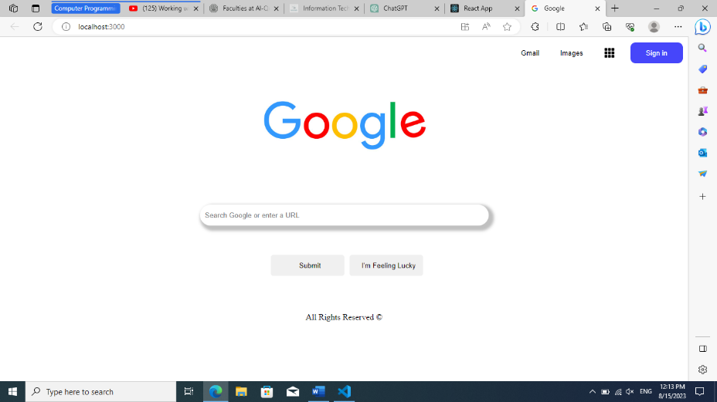

- Implement interactive elements on a web page using JavaScript and creating image slider .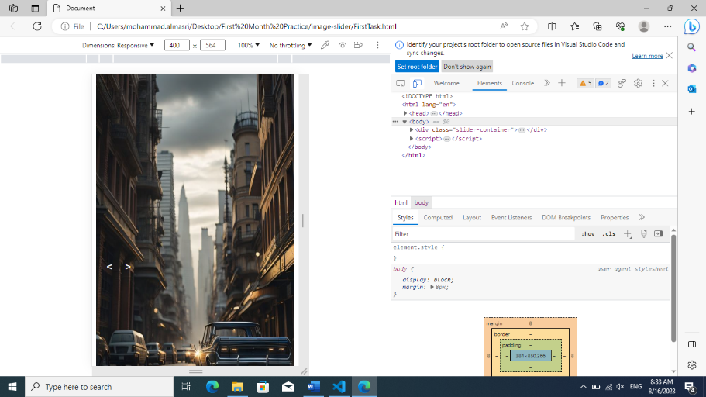

3-Simple React page to add blogs by using react implementation and JSON file:

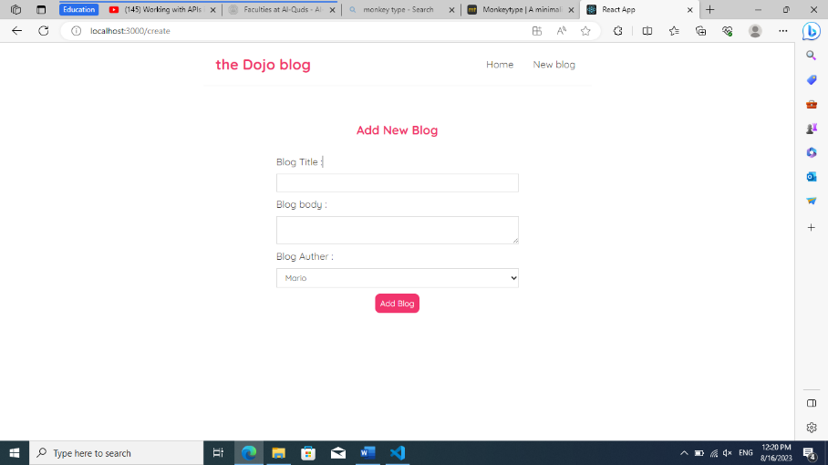

4- News API page by using react and API link.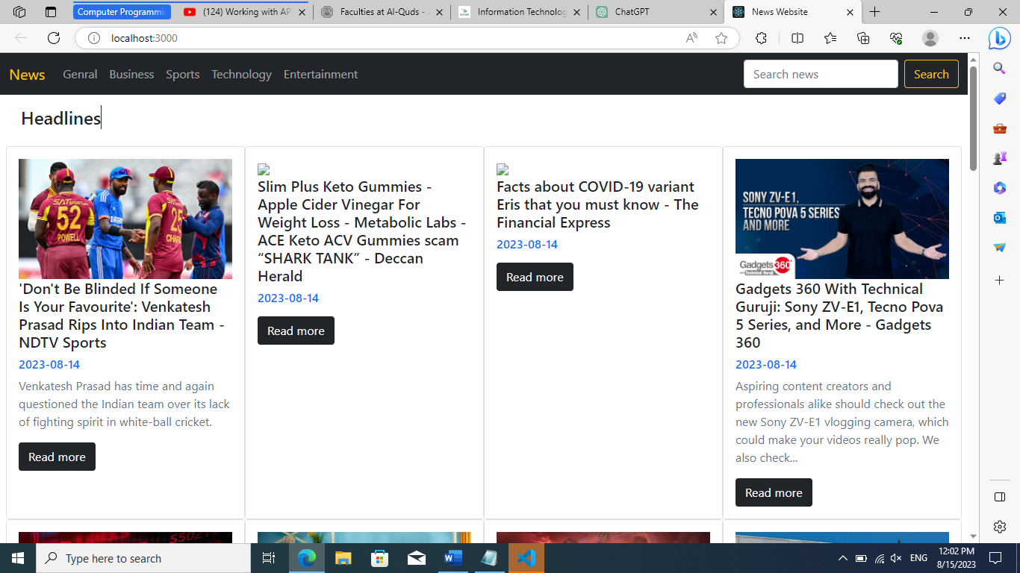

5- Product API page and inserting an active search bar (Filtering the data by the name, title and brand).
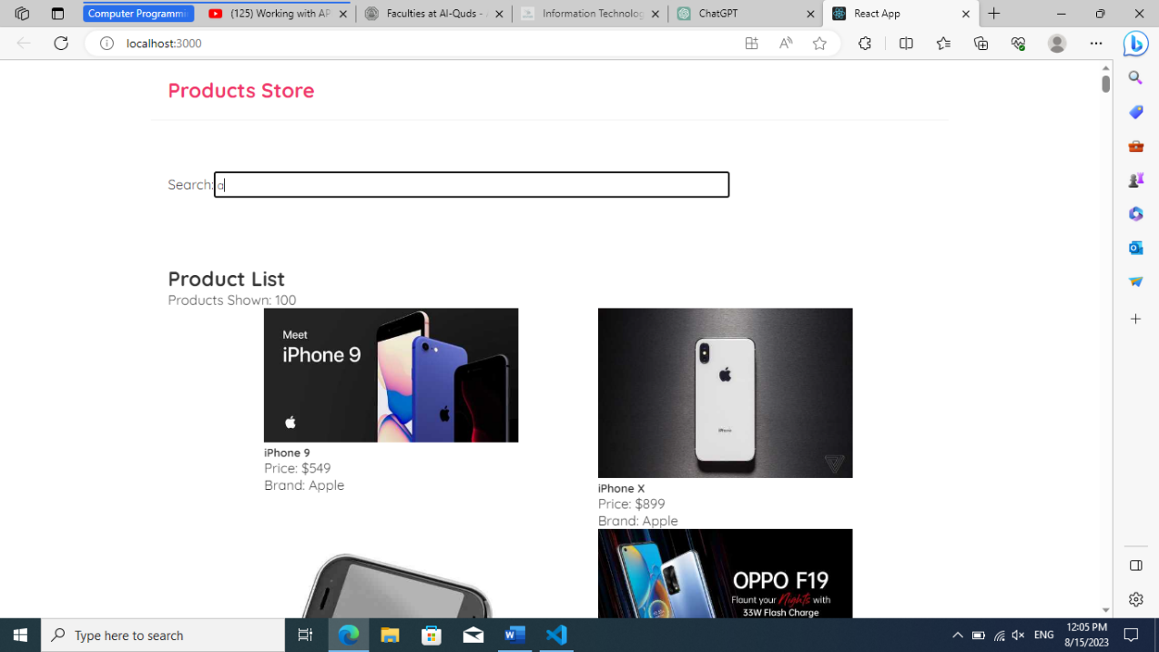

6- Starting on the database and creating tables and inserting value by SQL (SSMS) .
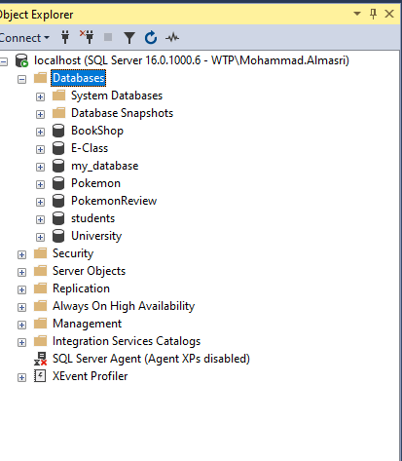
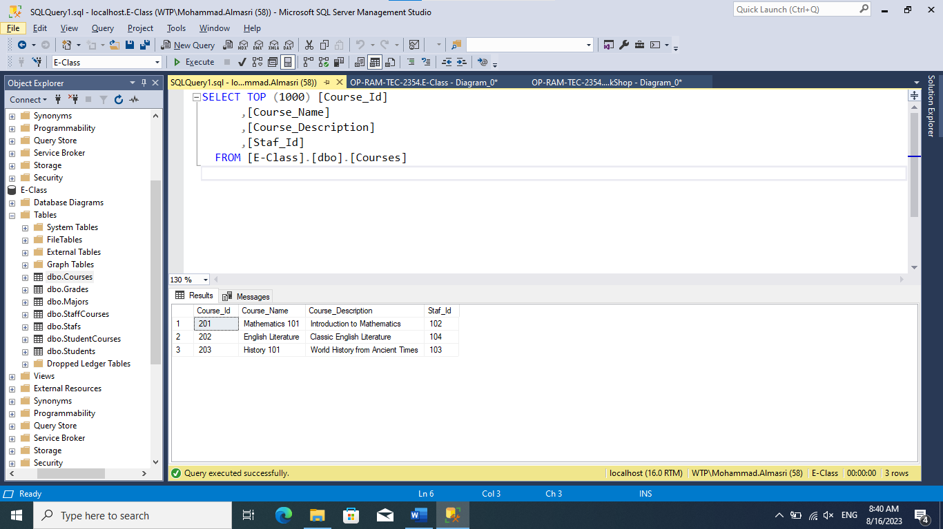

5- Create a relations between the tables. 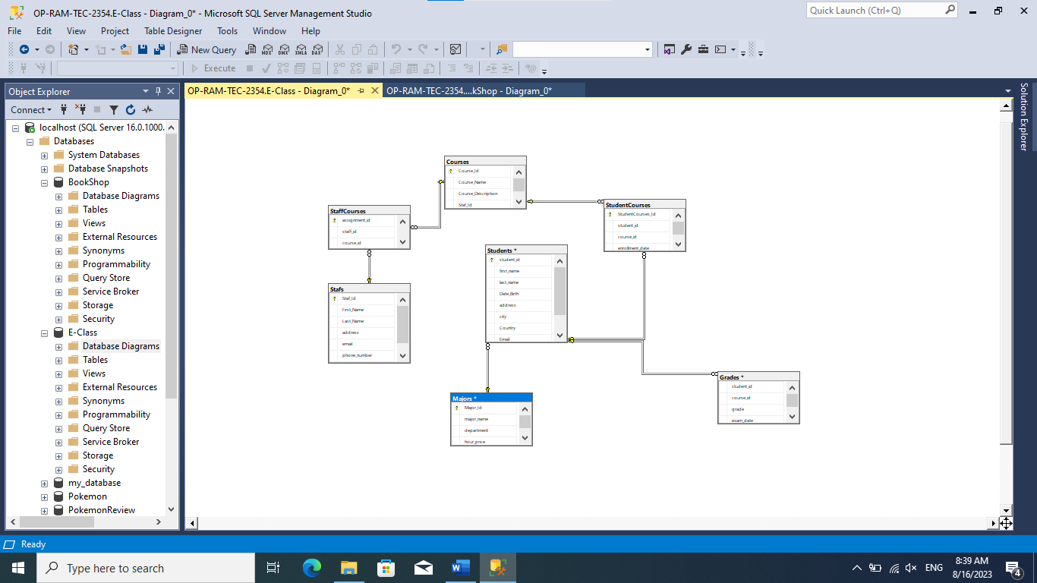

6- Back-End Development with ASP.NET: Setting up the development environment and creating routes. (Starting with Visual studio and connect it with the database(DB first /Coding First ) CRUD ).
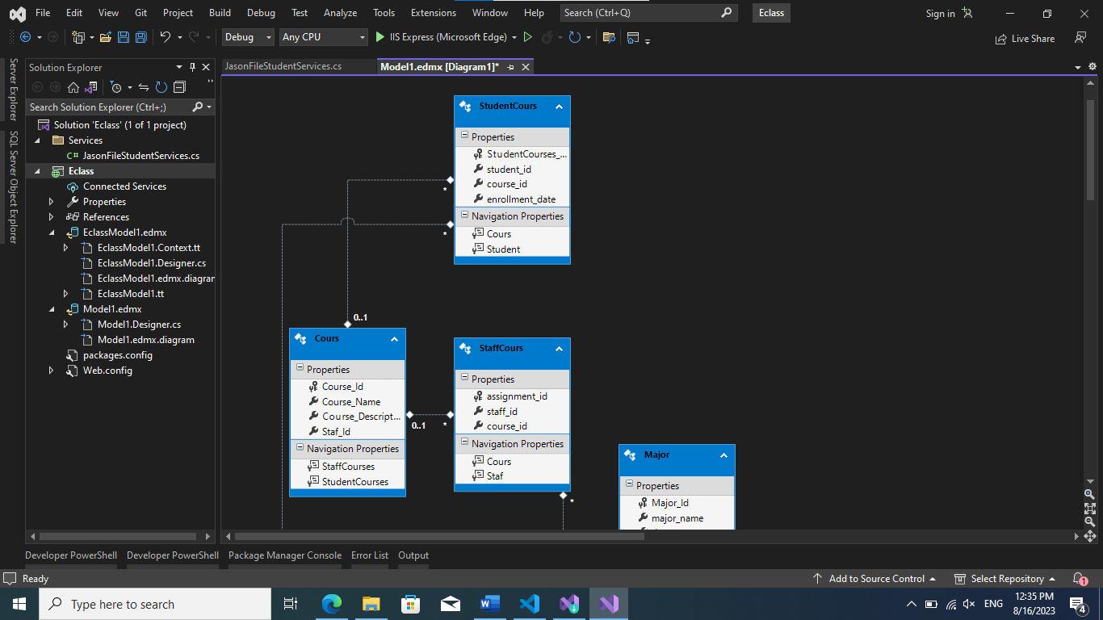

7- Here I Attached photos during the Practice period at Ooredoo company and during the volunteer at Al-Quds University.
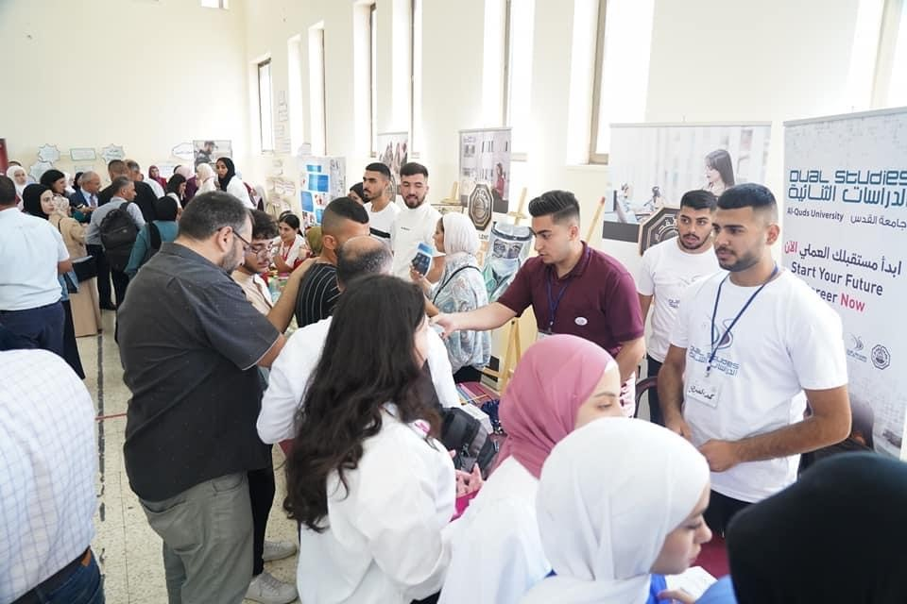

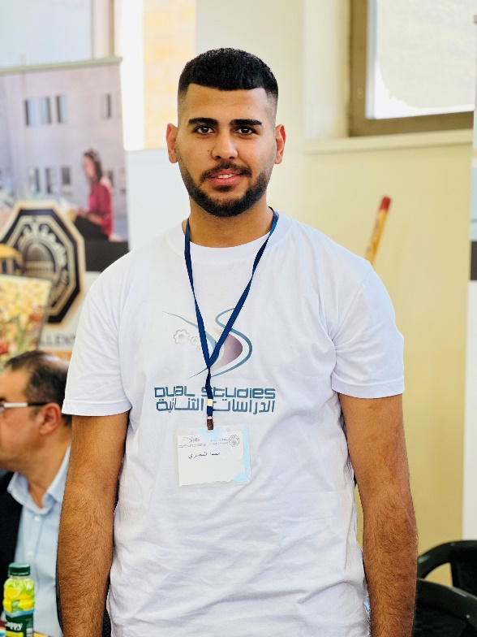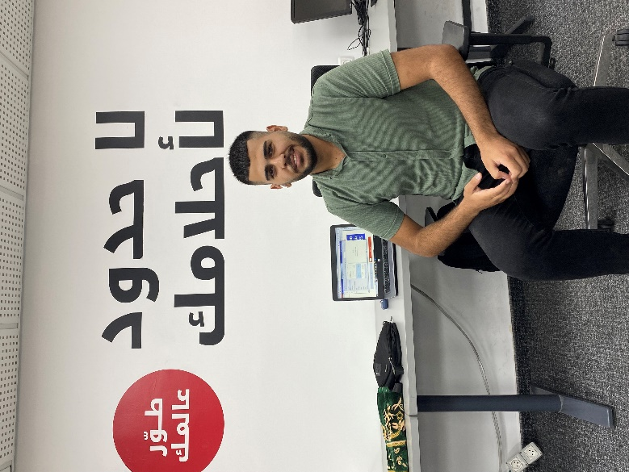

In conclusion, Thank You Dr. Raid I appreciate your interest.

